Abbas Mustanshir Galiyakotwala, (MCA)
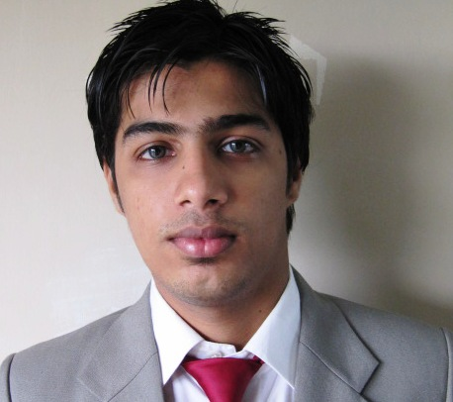
Surat | Gujarat | India
Phone: +919033575011
Email: abbas_galiyakot@yahoo.co.in
Employment Objective:
To use my skills in the best possible way for achieving the company’s goals and to enhance my professional skills in a dynamic and stable workplace.
Summary Of Qualifications:
- Master Degree
- 2 years & 8 month of experience in IT field.
- Visual Studio .Net 2.0/3.0/3.5 C# & LinQ(Above-average Expertise)
- Relational Database Systems ( SQL Server, Average Level Expertise)
- Stored Procedure Development (Senior Level Expertise)
- ASP .NET Web Development using MVC (Senior Level Expertise)
- ASP .NET Web Development using Web Forms (Average Level Expertise)
- Object Oriented Programming (Average Expertise)
Skills:
Visual Studio.Net: Have developed ASP.net websites. Experience of heading up a team development environment on major .net projects. Good understanding of the CMS (Content management System) projects. Cross Browser Development
MS SQL Server: (2005/2008) Tables, Triggers, Views, stored procedures, some DBA functions. Design and normalization of databases.
C# with Linq
Web Design, Installation, Maintenance, Development: Html, JavaScript, jQuery, ASP.Net, Kendo Ui, Experienced in cross-browser web site development and mobile application using Phone Gap
Third Party Web Comment: Experience with telerik control specially kendo ui.(http://www.telerik.com/kendo-ui)
Repository management: Experience in GIT and SVN
Experience Details:
Total Experiance: 2 years and 8 month of experience in Web development using Asp.net MVC
Recent Positions: Senior Developer (August 2012 –Till Date)

Projects:
Major Projects:

Web portal (U.A.E)
URL | http://massarsolutions.ae
Environment | ASP.NET using C# & Linq 4.
Templates | MVC and Web Forms
Database | MS-SQL Server 2005,2008
Role | Sr. developer
Team Size | 4
Responsibilities | Involved in Development , Db Design, Deployment
Description: Web portal and admin portal for fleet and supply chain management.

Web portal (Australia)
URL | http://www.finnewsnetwork.com.au/
Environment | ASP.NET using C# & Linq 3.5.
Templates | MVC and Web Forms
Database | MS-SQL Server 2005,2008
Role | Sr. developer
Team Size | 4
Responsibilities | Involved in Development , Db Design, Deployment
Description: Content Management System is used to Create, Edit, Manage, and Publish the website, basically Finance News Network is an site help find out Finance News including Company latest news, Company Reports , Fund management, expert commentary and many more

Web portal (Australia)
URL | http://www.nhp.com.au  http://www.tia-solutions.com  http://www.vint.com.au  http://www.sanskartrust.edu.in  http://www.champagnediamonds.com.au  http://www.carat-diamonds.com.au  http://www.iprogrammer.com.au  http://www.ipadforms.com.au/  https://mobile.nhp.com.au/whsanalysis/
Environment | ASP.NET using C# 3.5
Database | MS-SQL Server 2005
Templates | MVC and Web Forms
Role | Sr. developer
Team Size | 4
Responsibilities | Involved in Development , Db Design, Testing
Description: Content Management System Site, Create, Edit, Manage, and Publish the website.

Other Projects:

Web Portal
URL | http://m.slatergordon.com.au/  http://aliveapp.mobi/
Environment | ASP.NET using C# 3.5.
Database | 2005
Templates | MVC
Role | Jr. developer
Team Size | 2
Responsibilities | Involved in Development , Db Design, Deployment
Description: Content Management System Site, Create, Edit, Manage, and Publish the website.

Mobile Application
URL | https://play.google.com/store/apps/details?id=com.app.ipro.kidsTeeth&feature=search_result
Environment | Phone gap, Html, Javascript and CSS
Role | jr. developer
Team Size | 3
Responsibilities | Involved in Development , Db Design, Testing
Description: This App’s is an ideal ready reference for parents to monitor their child’s tooth development, identify potential problems and covers what to do in the case of an emergency.

Education:

Master of Computer Application (M.C.A) from Gujarat Technical University (G.T.U) With 83 CGPA
From 2008-2009 to 2011-2012 (3 years course)

Bachelor of Commerce (B.com) from Veer Narmad South Gujarat University with first class
From 2005-2006 to 2007-2008 (3 years course)

Other Certificate:

A Microsoft Certificate from aptech institute

Personal Information:

Date of Birth: 29-jan-1988
Languages Known: English, Hindi, Urdu and Gujarati
Marital Status: Unmarried
Achievement: http://stackoverflow.com/users/1887150/abbas-galiyakot
DECLARATION: I, Abbas Mustanshir Galiyakotwala, hereby declare that the above contents are true to the best of my knowledge.

